**UNIT TESTING**

Unit testing involves the testing of each unit or an individual component of the software application. It is the first level of functional testing.

The aim behind unit testing is to validate unit components with its performance.

A unit is a single testable part of a software system and tested during the development phase of the application software.

**1) Test Case ID: T1**

**Test Case Purpose:** Validate workflow –WF_S_ M_MAP_PROJECT_ROUTER_RANK

**Test Procedure:**

1. Go to workflow manager
2. Open workflow
3. Workflows menu-> click on validate

**Input Value/Test Data:** Sources and targets are available and connected.

Sources: BOOK_DETAILS

Mappings: M_MAPP_PROJECT_ROUTER_RANK

Targets: PROJ_TRG1_RANK1,

PROJ_TRG1_RANK2,

Session: S_M_MAP_PROJECT_ROUTER_RANK

Transformations:

1.Router: We defined two groups in the router as G1 and G2.We used G1 to get book price from 100 to 350 and we used G2 to get the book from 351 to 700.

2.Rank- RANK Transformation is used to rank according to the MRP of a book.

**Expected Results:** Message in workflow manager status bar: “Workflow WF_S_M_MAP_PROJECT_ROUTER_RANK is valid “

**Actual Results:** Message in workflow manager status bar: “Workflow WF_S_M_MAP_PROJECT_ROUTER_RANK is valid “

**Remarks: Pass**

**Tester Comments:**

Retrieved the data from source table SALES_DETAILS and grouped it in 2 categories BID , Title, MRP using transformations. The output is useful to identify the costliest and cheapest books in the store.

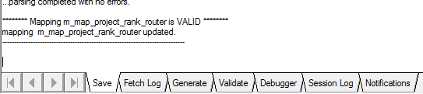

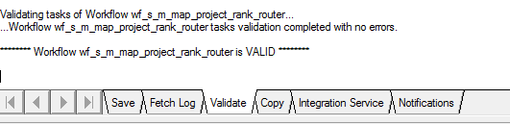

**2) Test Case ID: T2**

**Test Case Purpose:** Validate workflow –WF_S_ M_MAP_PROJECT_FILTER_AGG

**Test Procedure:**

1.Go to workflow manager

2.Open workflow

3.Workflows menu-> click on validate

**Input Value/Test Data:** Sources and targets are available and connected

Sources: SALES_DETAILS

Mappings: M_MAPP_PROJECT_FILTER_AGG

Targets: PROJ_TRG3_FILTER

Session: S_M_MAP_PROJECT_FILTER_AGG

Transformations:

1. Sorter: We have used the sorter to get the data in ascending order of CID.

2. Expression: We have used the expression to find the total price.

3. Aggregator: We have used the aggregator to find the sum of total price and to find the total bill of each customer. We have also applied a discount on the total bill.

4. Filter: We used it to filter the customer id’s.

**Expected Results:** Message in workflow manager status bar: “Workflow WF_S_M_MAP_PROJECT_FILTER_AGG is valid “

**Actual Results:** Message in workflow manager status bar: “Workflow WF_S_M_MAP_PROJECT_FILTER_AGG is valid “

**Remarks: Pass**

**Tester Comments:**

Retrieved the data from the SALES_DETAILS and sorted,aggregated to find the bill the customer has to pay. This data will be useful to know billing details of each customer.

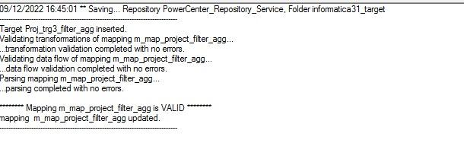

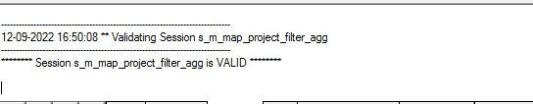

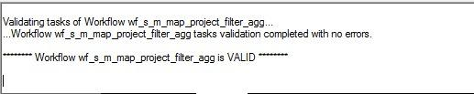

**3) Test Case ID: T3**

**Test Case Purpose:** Validate workflow –

WF_S_ M_MAP_PROJECT_AGG_FLATFILE

**Test Procedure:**

1.Go to workflow manager

2.Open workflow

3.Workflows menu-> click on validate

**Input Value/Test Data:** Sources and targets are available and connected

Sources: TRG_FLATFILE1.TXT

Mappings: M_MAP_PROJECT_AGG_FLATFILE

Targets: PROJ_TRG7

Session: S_M_MAP_PROJECT_AGG_FLATFILE

Transformations:

1. Aggregator: We have used the aggregator to find the most popular book.

2. Expression: WE have used the expression to handle the null values.

**Expected Results:** Message in workflow manager status bar: “Workflow WF_S_M_MAP_PROJECT_AGG_FLATFILE is valid “

**Actual Results:** Message in workflow manager status bar: “Workflow WF_S_M_MAP_PROJECT_AGG_FLATFILE is valid “

**Remarks: Pass**

**Tester Comments:**

Retrieved the data from TRG_FLATFILE1.TXT and used the aggregator transformation on the data. This data is used to find the mostly sold out book and also the books which are not sold at least once.

